If any filed is missing ,Instead of missing fileds we are getting “File size grater than 4MB”.

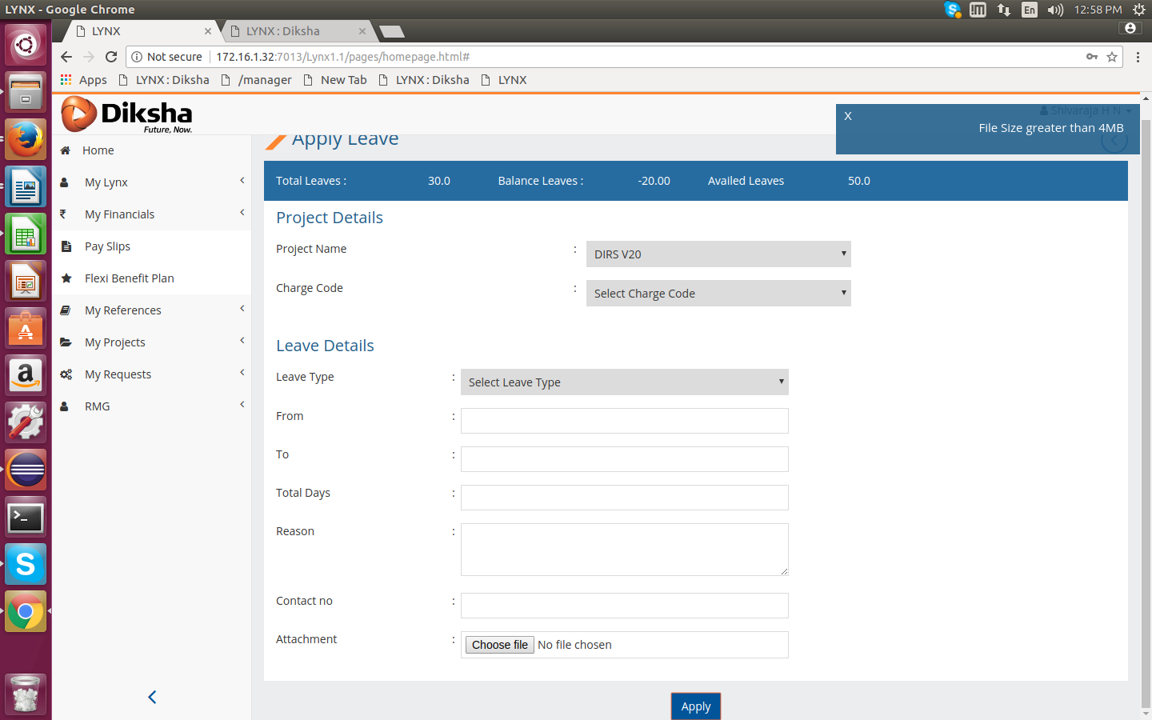
2. While applying a leave after giving all information when click on apply button getting “File size grater than 4MB”.error message .

